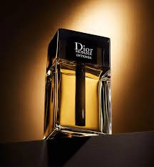
DIOR PERFUME
Product Overview
Dior fragrance reflects timeless elegance and refined masculinity. Its rich blend of citrus, spicy, and woody accords creates a bold yet sophisticated scent profile. Designed for men who appreciate luxury, this fragrance enhances your presence with confidence and charm, making it perfect for formal gatherings and evening occasions.
Key Features
* Brand: Dior
* Category: Men
* Volume: 100ml
* Fragrance Type: Eau De Parfum
* Strong projection with premium finish
* Long-lasting performance (8+ hours)
Pricing
Old Price: Rs. 2500
Discounted Price: Rs. 2250

